**N.Y Tajms Studios proudly presents!**

**a tajms opengl production**

**in association with bth**

**pacman 3d**

**Group Members:**Eric Ahlström  
John Bergsten  
Lucas Holmqvist  
Christian Markowicz  
Konrad Öhman

Contents

Architecture Diagram 2

Game-specific Subsystem 3

Front-end System 3

Gameplay Foundations 4

Visual Effects 4

Low-Level Renderer 4

Debugging 5

Collision and physics 5

Audio 5

Human Interface Device 5

Resources 6

Core Systems 6

3rd Party SDKs 6

OS and Platform 6

Domain Modell 7

Work Breakdown Structure 8

References 10

# J:\Pacman\ArchitectureDiagram.pngArchitecture Diagram

## Game-specific Subsystem

This block contains components that are specific for this game, for example candy, ghost, camera etc.

**Camera** contains functions to build a first person camera and a free moving camera. The free moving camera is for debugging while the first person camera is for the final product.  
**AI** directs the ghosts movement by sending a map of directions to each ghost. It also tells the ghost whether to flee from Pacman or to chase him.   
**Player mechanics** uses the player input, from the mouse and keyboard, to control the direction of the camera and Pacmans position.  
**Game-specific Rendering** holds info on how to render the terrain and the different objects.  
**Candy** holds a position to where the candy is.  
**Ghosts** are the main enemy. They hold a map on where to go which they get from the AI and a state, whether to chase or flee.  
**Buffs** change the state of Pacman. The most basic of buffs is that he can eat the ghosts for a specific amount of time.

## Front-end System

Contains HUD and GUI. These are things that don’t interact with the gameplay but rather shows info that is useful to the player and directs the player to different places of the program.

**HUD** is short for Heads Up Display. It contains different information like score, HP, if Pacman can eat the ghosts etc.  
**GUI** is short for Graphical User Interface. This includes different menus which navigates the player to different places in the program.

## Gameplay Foundations

This block contains map loading, different static objects (like spawn points) and a event/messaging system.

**Map Loading** reads the map and saves both a logical representation of the map, for collision detection and pathfinding, and a graphical representation that is sent to the graphic interface for on-screen representation.  
**Static World Elements** are elements/objects that are in the same place throughout the game, like spawn points.  
**Event/Messaging System** gives the player information about gameplay states, for example when the ghosts changes state from fleeing to chasing.

## Visual Effects

The visual effects of the program includes point light(s), different particle effects, reflections and an environment map.

**Point Light** is a source of light with a direction and a source point. It is the main source of light in our game  
**Particle Effects** is a way to demonstrate small particles with different movement patterns. Explosions are represented by particle effects.  
**Reflections** put a texture on a surface that represents the view of the surface.  
**Environment Map** controls background textures.

## Low-Level Renderer

Contains information that draws the graphic.

**Shaders** are programs that reside in the gpu. They tell the gpu how to paint every pixel on the screen.   
**Cameras** are matrices that convert the world into different views.  
**Text And Fonts** are outputs to the gui and can also be used for debugging. The fonts tell the text how to display itself.  
**Textures/Surface Management** puts the correct texture on the right object. This includes surfaces.  
**Graphics Device Interface** is the interface towards the low-level renderer.

## Debugging

Is used to check the program code for bugs, glitches and performance issues.

**Performance and memory stats** keep stats about performance. For example fps, memory loss etc.  
**Debug Drawing** prints the map and objects in different ways. Can be used for drawing the outlines of triangles only.

## Collision and physics

Functions that are used for gameplay events and changes for example Pacman collides with an enemy and is killed.

**Physics / Collision World** use positions to check if a move is prohibited.

## Audio

Plays sounds and music depending on the position of Pacman.

**Audio Playback / Management** controls what sounds to play and what volume it should be played at. The volume depends on the distance from the audio source and Pacman.  
**3D Audio** makes the sound appear different in each output device.

## Human Interface Device

Mouse and keyboard are the only interface devices that the player can use.

**Physical Devices.** The keyboard is used to control Pacman left, right, up and down. The mouse is used to control the camera and Pacman’s direction.

## Resources

Useful files for our program.

**Textures** files with colors that we can attach to an object.  
**Fonts** information that describes the way a text should be written.  
**World Map** stores information about how the vertices are to be constructed and how the logical map will be contracted. Uses a .raw file to store the information.  
**3D-models** are stored in .obj files with information on how to construct the vertices for a 3D-object.

## Core Systems

These are the different libraries that helps us with predefined methods.

**Assertions** check the code for logical error like misspelling or forgotten characters.  
**Memory Management** helps with deleting memory places that won’t be used again. This makes memory loss less frequent.  
**Math Library** gives structures and mathematical calculations on more advanced variables.  
**Random Generator** uses the CPU clock to give the user a seemingly random number.

## 3rd Party SDKs

These are the libraries, dlls and .h files needed to do more advanced stuff. These are programmed by a 3rd party.

**Open GL 4.x** is the SDK that will be used to manage the GPU. It, among other stuff, sends buffers to the GPU and tells it what shaders are to be used.  
**SOIL** helps with reading in textures.

## OS and Platform

This game will be programmed for Windows 7 using a pc.

# Domain Modell

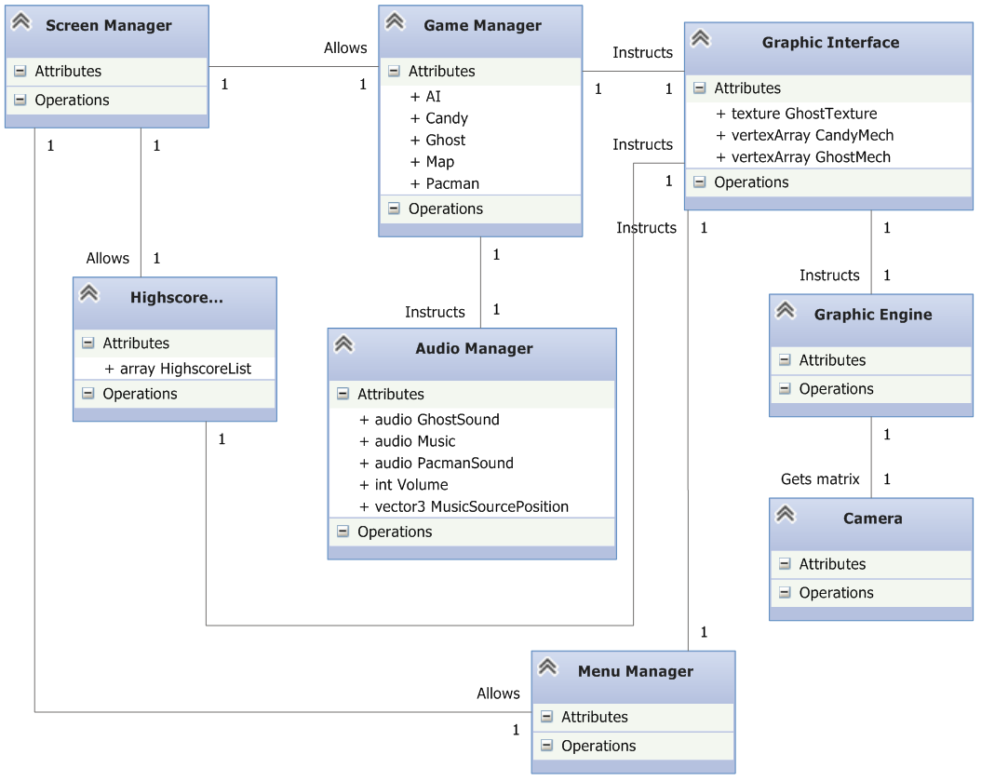

# Work Breakdown Structure

|  |  |  |  |  |  |  |
| --- | --- | --- | --- | --- | --- | --- |
| **Task** | **Start Date** | **Duration(days)** | **End Date** | **Est. Time(h)** | **Act. Time(h)** | **Act. Time/ Est. Time(%)** |
| Gameplay Design (1) | 20-jan | 4 | 23-jan | 2 | 2 | 100,00% |
| Achitecture/Design (1) | 21-jan | 3 | 23-jan | 58 | 58 | 100,00% |
| Wbs (1) | 23-jan | 1 | 23-jan | 3 | 7 | 233,33% |
| Writing L1 | 23-jan | 1 | 23-jan | 12 | 11 | 91,67% |
| **Total L1** | **20-jan** | 5 | **24-jan** | **75** | **78** | **104,00%** |
| R1 | 26-jan | 1 | 26-jan | 10 |  | 0,00% |
| Detailed L1 | 27-jan | 4 | 30-jan | 50 |  | 0,00% |
| Architecture/Design (2) | 27-jan | 4 | 30-jan | 5 |  | 0,00% |
| Gameplay Design (2) | 27-jan | 4 | 30-jan | 2 |  | 0,00% |
| Writing L2 | 31-jan | 1 | 31-jan | 10 |  | 0,00% |
| Changes in L1 | 31-jan | 1 | 31-jan | 5 |  | 0,00% |
| Wbs (2) | 31-jan | 1 | 31-jan | 2 |  | 0,00% |
| Total L2 | 27-jan | 5 | 31-jan | **84** | **0** | **0,00%** |
| R2 | 02-feb | 1 | 02-feb | 10 |  | 0,00% |
| Resources | 03-feb | 3 | 05-feb | 15 |  | 0,00% |
| Low-level Renderer | 03-feb | 4 | 06-feb | 40 |  | 0,00% |
| Gameplay foundations | 03-feb | 4 | 06-feb | 40 |  | 0,00% |
| Debugging | 07-feb | 1 | 07-feb | 10 |  | 0,00% |
| R3 | 09-feb | 1 | 09-feb | 10 |  | 0,00% |
| Audio | 07-feb | 7 | 13-feb | 50 |  | 0,00% |
| Visual Effects | 10-feb | 5 | 14-feb | 50 |  | 0,00% |
| R4 | 16-feb | 1 | 16-feb | 10 |  | 0,00% |
| Collision and Physics | 07-feb | 11 | 17-feb | 35 |  | 0,00% |
| Front End | 17-feb | 3 | 19-feb | 30 |  | 0,00% |
| Optimization | 18-feb | 2 | 19-feb | 20 |  | 0,00% |
| Documentation | 18-feb | 2 | 19-feb | 20 |  | 0,00% |
| Record Prototype | 20-feb | 2 | 21-feb | 20 |  | 0,00% |
| Total L3 | 03-feb | 19 | 21-feb | **360** | **0** | **0,00%** |
| R5 | 23-feb | 1 | 23-feb | 10 |  | 0,00% |
| Balancing | 24-feb | 2 | 25-feb | 20 |  | 0,00% |
| Modding | 24-feb | 3 | 26-feb | 30 |  | 0,00% |
| Update L1,L2 & L3 | 24-feb | 3 | 26-feb | 15 |  | 0,00% |
| Evaluations | 27-feb | 2 | 28-feb | 50 |  | 0,00% |
| R6 | 02-mar | 1 | 02-mar | 10 |  | 0,00% |
| Progress Report | 03-mar | 1 | 03-mar | 25 |  | 0,00% |
| Total L4 | 24-feb | 8 | 03-mar | **160** | **0** | **0,00%** |

# References

We have used the course main literature as a template for our architecture diagram. We have removed some of the content that they had since we found it unnecessary for this project. [1] For example we decided to not include skeletal animations on the basis that it is pointless in such a simple game as Pacman.

1. Game Engine Architecture, Jason Gregory, 2009 Taylor and Francis group, p.29